AI Design V1

(Red: you; Yellow: Breakable bricks;
Green: Enemy; Dark gray: Unbreakable bricks)

Level 1
Map:
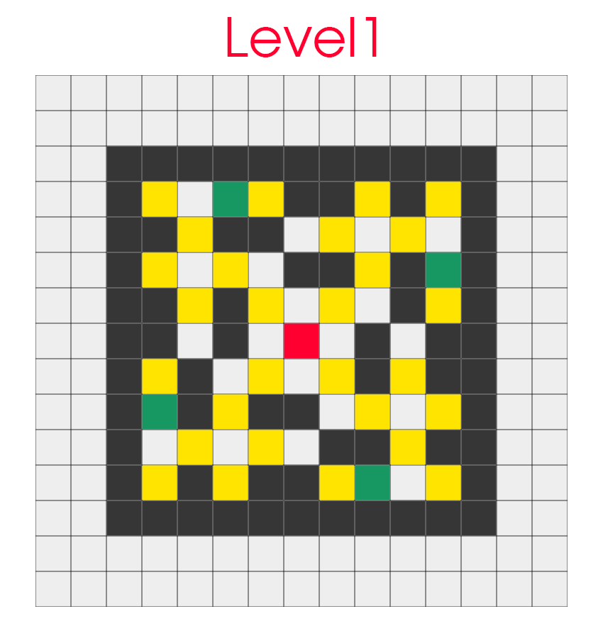

Routes:
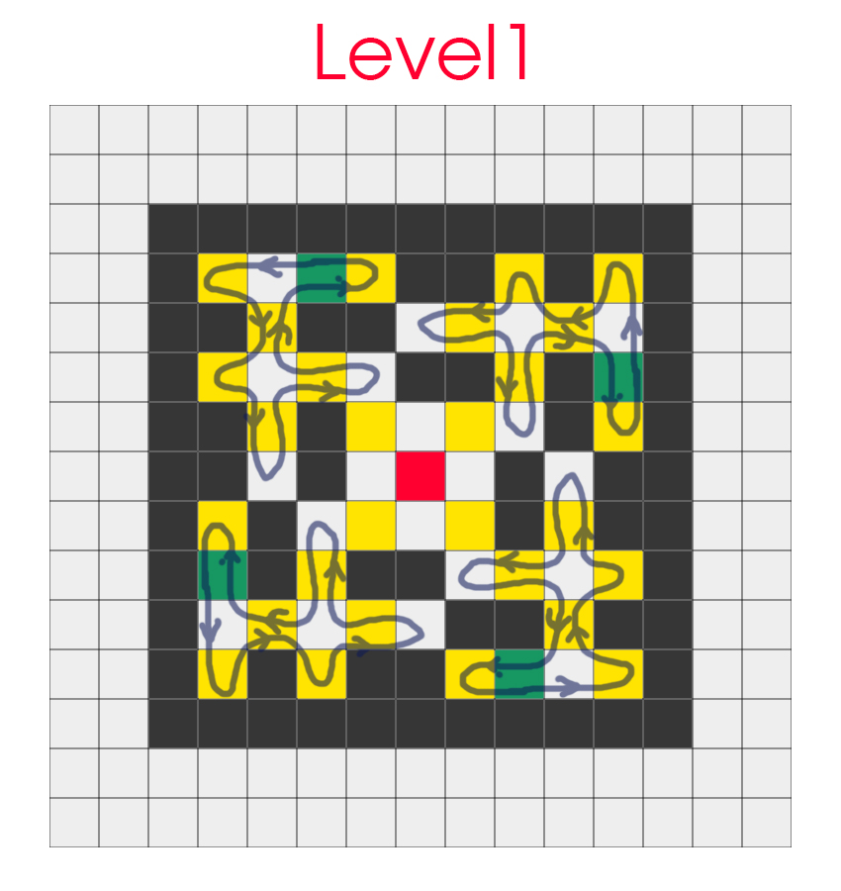

AI design:
4 enemies are walking according to specific routes and if they are blocked, they will change the direction and still walking though the certain routes.

Flaws: Enemies won’t be affected by you unless you block in their routes and they don’t have the ability to avoid canons and active canons.

Level 2
Map:
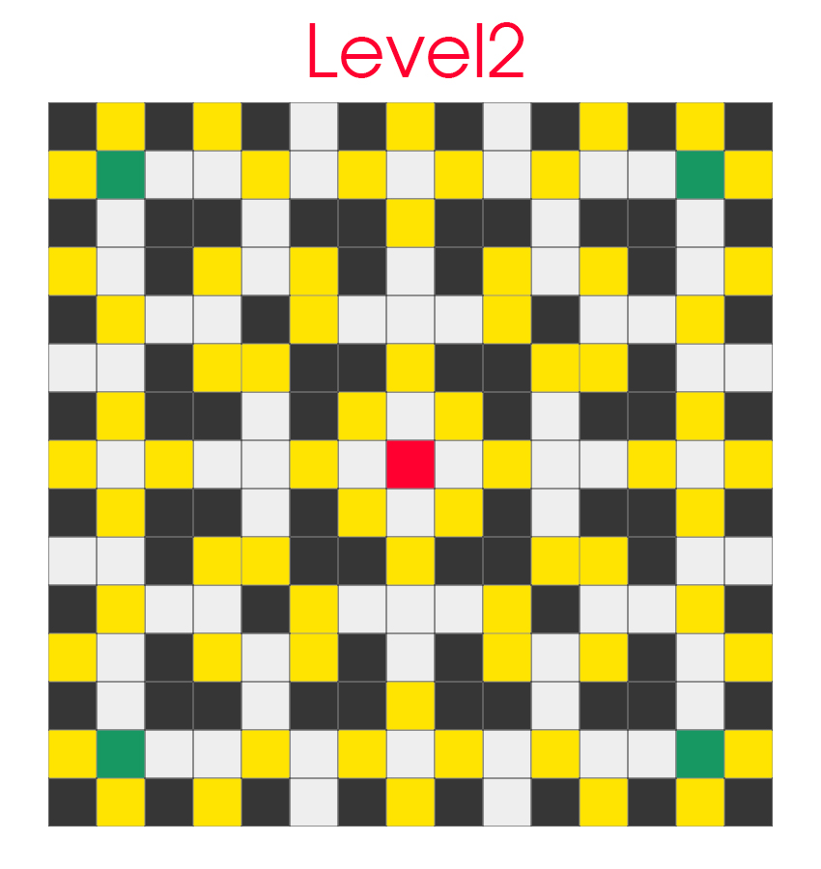

Example:
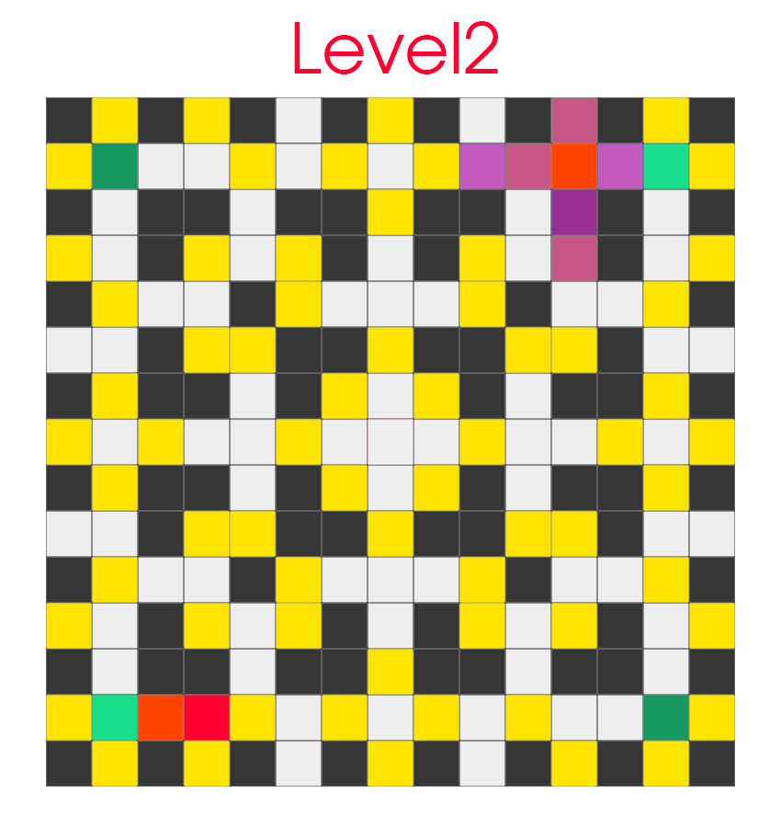

AI design:
4 enemies can walk randomly and if they detect that there is no way out, they will activate the canon next to breakable bricks(like the one in the top-right corner). And if enemies detect that they are in the purple area(where they can be destroyed by canon), they will see the area as forbidden area and walk to safe area. If an enemy sees another enemy or you, he will activate the canon next to you which is between you two.

Flaws:Enemies don’t have the sense of time and if they are not able to get out of the purple area, they won’t know where to go. They can only activate one canon at a time. Enemies destroy each other.

Level 3
Map:
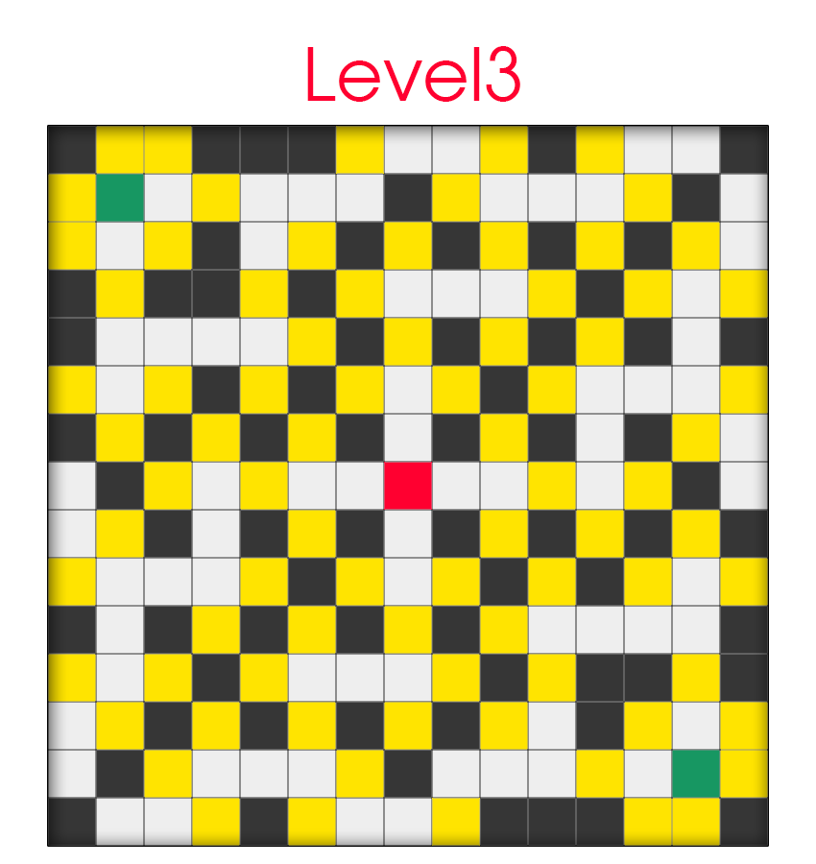

Example:
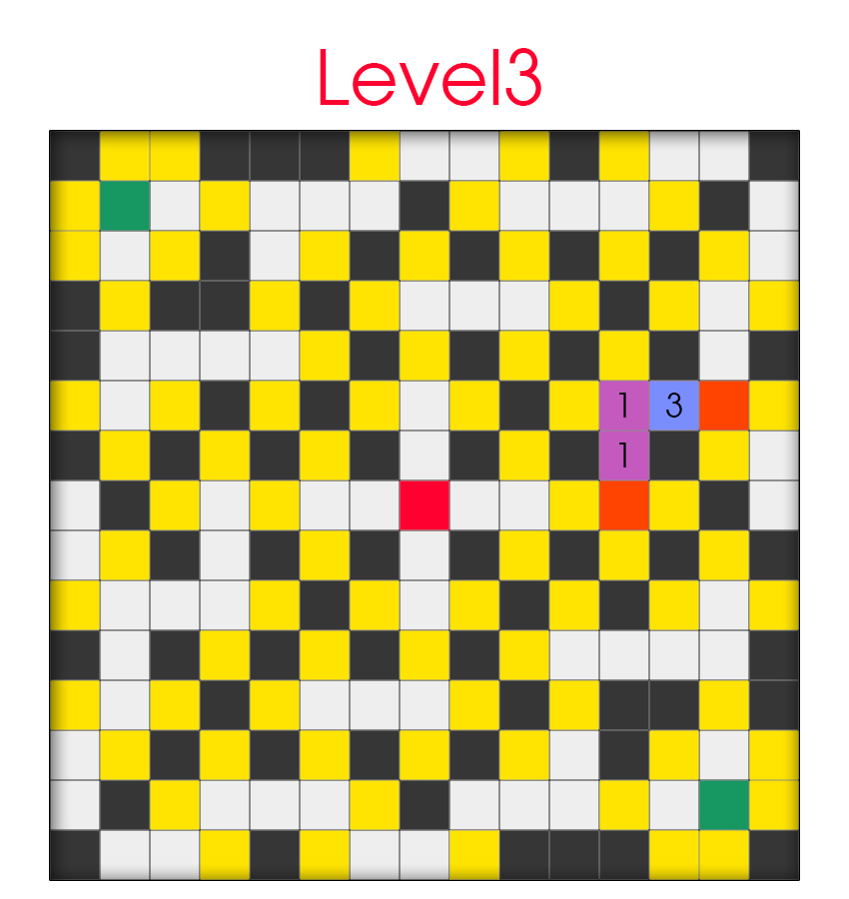

AI design:
2 enemies now has the sense of time. If they are caught in the area and there is no safe place, they will walk to the relatively safer place. For example, there are two canons. One is about to launch in 1 sec and another is launching in 3 sec. The enemy caught between will walk to the blue area and get out of the purple area. If the enemies see each other, they won’t hurt each other. But if one enemy sees you, it will activated the canon beside you and it can activate at most 5 canons at one time. The canons in this level are also more powerful, it can shoot as far as 4 unit cells(initial design).

How to implement to Code!

